# Fetch when leader have active developments:

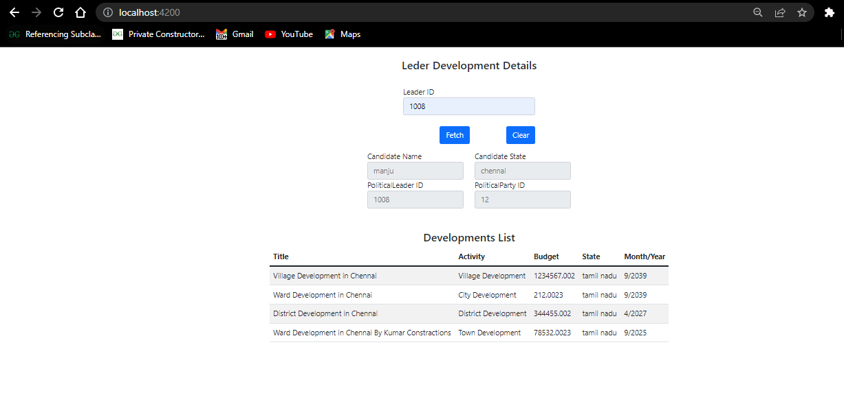

# Trying to get Developmets when user have no active developments

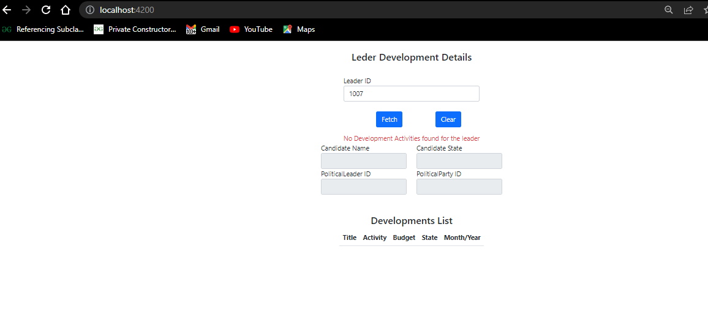

# Trying to get deveopments when user not registered to any party.

